**Assignment7**

**1301058**

**Zhang Junming**

**exercise 1**

Question

Define a structure type library book to represent each book in the library. Each book should be identified by the following IDs: book name (string), author name (string) and a library ID number (2 characters plus 7 digits). In this assignment, only “Sc” and “EN” are used (stand for science and engineering)) as the 2 characters in the library ID number.

Model Answer

Software Development Process

1. **Problem statement**

Write a C program, ask user to choose functions, one is initialize a new book and the initialized new book could add into the file (librarybooks.txt) which contains all the books the library has. Another is when user search book name, display the detail about this book, if not find this book, tell user that library does not have the book.

1. **Analysis**

Inputs:

1. The details about added book: (Book name, Author name and Library ID).
2. The book name which user wants to search.

Outputs:

1. Details about added book in Librarybooks.txt
2. Details about searched book.

Additional requirements or constraint

In library ID, only “Sc” and “EN” are used (stand for Science and

Engineering)

**3. Design**

Algorithm

1. Adding ‘stdio.h’ ,‘stdlib.h’,’string.h’ and ’malloc.h’ library.
2. Define menu(), addbook() and searchbook() three defined function.
3. Create struct: library_book
4. char book_name-represents the name of added book.
5. char author_name-represents the name of book author.
6. char library_ID-represents 7 digits of the book ID number.
7. Write main function.
8. int choose-represents options.
9. Setting up a loop use ‘do while’, ask user to input a number choose functions, only input ‘3’ could out this loop.
10. Using defined function menu().
11. Ask user enter 1~3 to choose function.
12. Read and store entered number in **choose**.
13. Receive EHTER.
14. . Setting up ‘switch’ function of **choose**.

Case 1: using addbook defined function.

Case 2: using search defined function.

Case 3: display quit program.

Default when entered number is not in 1~3, display enter data error. Please enter again.

1. Write first defined function ‘menu ()’:

(1) Display the main menu.

(2) Ask user to input number to choose functions.

1. Write second defined function, ‘addbook()’:
2. Struct library_book lib-lode library_book in lib.
3. int choose - for choosing options.
4. int count – for counting.
5. Char ID1[10]=”Sc” – represents Science library ID number.
6. Char ID2[10]=”EN” – represents Engineering library ID number.
7. FILE *fp-represents librarybooks.txt
8. Tell user how to use this function add book.
9. Ask user input book name.
10. Read and store book name in **book_name**.

(10) Ask user input author name.

(11) Read and store author name in **author_name**.

(12) Ask user choose book types, 1 represents science book and 2 represents engineering book.

(13) Read and store entered number in **choose**.

(14) Receive EHTER.

(15) Judge **choose**, if **choose** equal to 1.

(1) Setting up a loop use “do-while”, when **count** equal to 7, out the loop.

(2) Add library ID to ID1 (add number behind Sc)

(3) Open librarybooks.txt

(4) Store and printf book name, book author and ID1 in librarybooks.txt.

(5) Close libraybooks.txt.

(6) Use system ‘pause’ and ‘cls’ clear screen after using this defined function.

(16) Judge **choose**, if **choose** equal to 1.

(1) Setting up a loop use “do-while”, when **count** equal to 7, out the loop.

(2) Add library ID to ID2 (add number behind EN)

(3) Open librarybooks.txt

(4) Store and printf book name, book author and ID2 in librarybooks.txt.

(5) Close libraybooks.txt.

(6) Use system ‘pause’ and ‘cls’ clear screen after using this defined function.

(17) Judge **choose**, if **choose** did not equal to 1 or 2, tell user enter 1 or 2 and return menu.

(18) Use system ‘pause’ and ‘cls’ clear screen after using this defined function.

1. Write second defined function, ‘searchbook()’:

(1) Struct library_book lib-lode library_book in lib.

(2) int i,j.count - for counting.

(3) char aim-represents the name of searching book.

(4) FILE *fp-represents librarybooks.txt

(5) char **bookname-for storing information in librarybooks.txt.

(6) Open librarybooks.txt.

(7) Setting up a loop use ‘while’, and counting how many items in librarybooks.txt.

(8) Return to the outset of librarybooks.txt.

(9) Request a block of memory of a give size for **bookname** and **bookname[i].**

(10) Setting up a loop use ‘for’, put each item in **bookname[i]**.

(11) Tell user how to follow this function.

(12) Ask user enter the name of searching book.

(13) Read and store data in **aim**.

(14) Setting up a loop use ‘for’, compare each item in **bookname[i]** and **aim**, if they are the same strings, display following information. At the same time, record the times which **bookname[i]** different with **item**.

(15) To release memory allocated with malloc().

(16) If the number of items and times of different items are same, display can’t find this book.

(17) Use system ‘pause’ and ‘cls’ clear screen after using this defined function.

(18) Close librarybooks.txt.

(19) Use system ‘pause’ and ‘cls’ clear screen after using this defined function.

1. **Implementation**:

See the C code in file exercise1.c with comments.

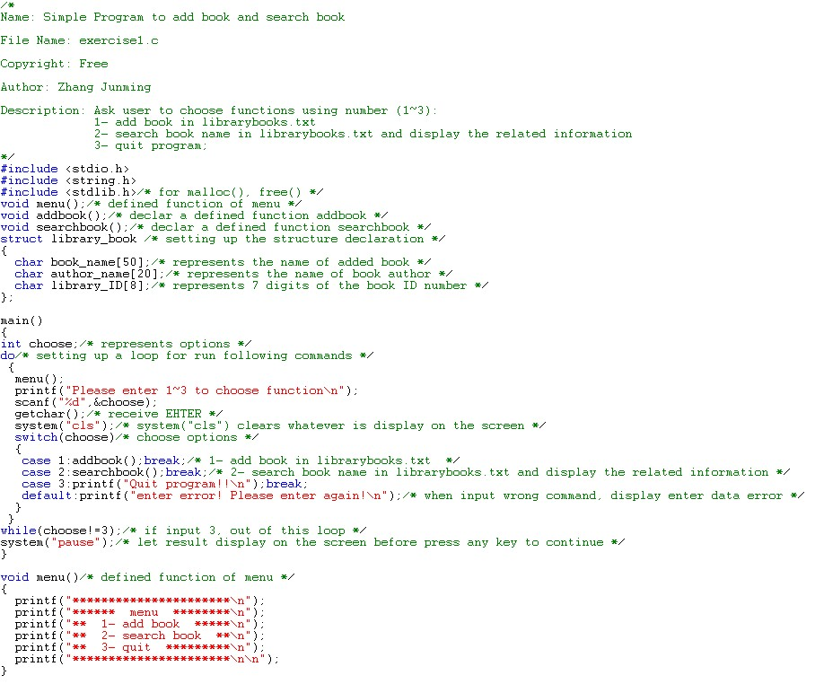

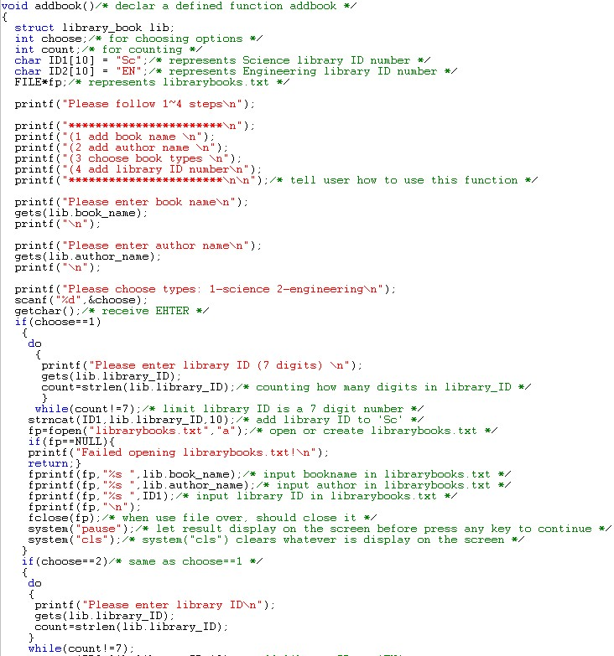

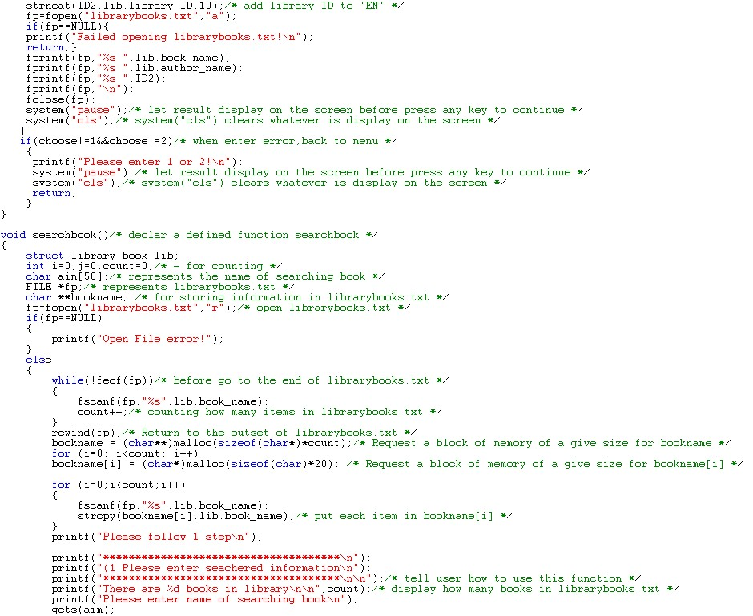

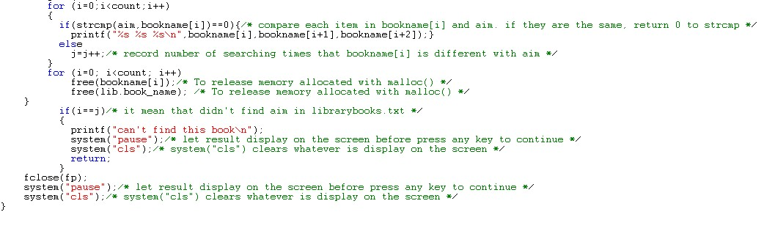

1. **Testing:**

The C program was tested by carrying out a set of experiments; and the C program output was verified successfully. For instance,

**Menu**

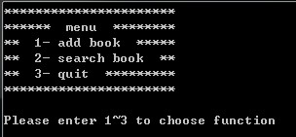

1. **Add book**

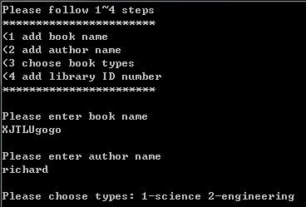

1 for science and 2 for engineering

When enter other number

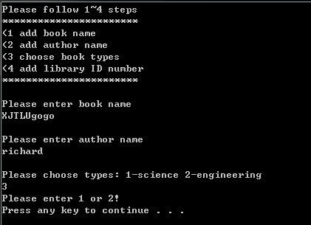

When enter 1 or 2

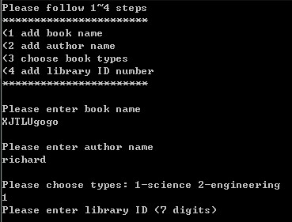

When enter error digits

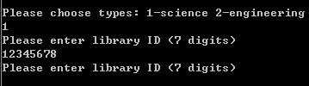

When enter right digits

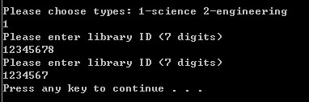succeed

Add to librarybooks.txt end



No space between Sc || EN and ID number

1. **Search book**

Little program to add random number which represents book information

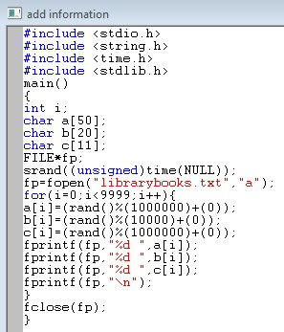

My librarybooks.txt



Need almost 10s to open this file when choose 2 to search book because librarybooks.txt is large

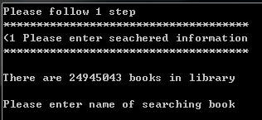

Enter existing book name

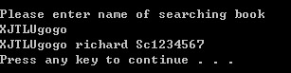

Enter not existing book name

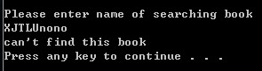

1. Quit

